FoodSafe



Um Alqura university
Applied college

Proposal by
Authors:

Supervisors
Dr.

Content
CHAPTER 1 Introduction 2
1.1 Introduction 3
1.2 The research problem 3
1.3 The purose of the project 3
1.4 Purpose of this Document 3
1.5 Existing System 3
1.6 Methodology 3
1.6.1 Project Plan and Timeline and Gantt chart 4
1.7 Summery 4
CHAPTER 2 SYSTEM ANALYSIS 5
2.1 Introduction 6
2.2 Functional Requirements 6
2.2.1 User Login (FR_001): 7
2.2.2 Function 2 (FR_002): 9
2.2.3 Function 3 (FR_003): 9
2.3 3. Dependencies 10
2.4 None- Functional Requirements 10
2.4.1 Security 10
2.4.2 Privacy 10
2.4.3 Ease of Use 10
2.5 Requirements Modelling UML 10
2.5.1 Use Case Diagram 10
2.5.2 Sequence Diagram 11
2.5.3 Activity Diagram 12
2.5.4 Class Diagram 12
2.6 Summary 12
CHAPTER 3 DESIGN CONSIDERATIONS 13
3.1 Introduction 14
3.2 Architectural Strategy 14
3.2.1 Presentation Layer (User Interface Layer): 14
3.2.2 Business Logic Layer (Processing and Notifications): 14
3.2.3 Data Layer (Storage and Synchronization): 14
3.3 Development Requirements 15
3.3.1 Hardware Requirements 15
3.3.2 Software Requirements 15
3.4 Graphic User Interface Design and wireframe 15
3.5 Summary 16
CHAPTER 4 CONCLUISON 17
4.1 Introdction 18
4.2 Challenges and learning experiences 18
4.2.1 Timeline 18
4.3 Furture work 18
4.4 Conclusion 18

List of figures

Figure 1– School System Login 11
Figure 2 Sequence Diagram – User Login 11
Figure 3 Activity Diagram – Login Process 12
Figure 4 Example of product wireframe and UI 16

List ofTable
Table 1 Functional Requirement – User Login 7

Abstract
Summary of the project

Chapter1: Introduction

1.1 Introduction
This project aims to develop a system based on the Internet of Things (IoT) to monitor and track food safety during transportation.
The system measures key factors such as temperature, humidity, and gas emissions inside the trucks, and then sends the data instantly to a simple platform or application to track it.
This project belongs to the field of Information Technology and the Internet of things with direct application in the food, transport and distribution sector.
The importance of the project lies in its role in ensuring the quality and safety of food, reducing spoilage and losses during transportation and storage, which supports food security and increases consumer confidence in food products.

1.2 The research problem
Food transported in trucks is often exposed to various environmental factors such as temperature fluctuations, humidity, and gas emissions, which may lead to its spoilage during transit. This highlights the need for improved monitoring and control to ensure food safety and quality throughout the transportation process.

1.3 The purose of the project
The purpose of this project is to develop a prototype IoT-based system for monitoring and tracking food safety during storage or transportation, ensuring product quality, reducing the risk of spoilage, and supporting food security.

1.3.1 Main Objective of the Project
1.3.1.1 To develop a prototype capable of reading basic data such as temperature, humidity, and gas emissions.
1.3.1.2 To transmit the collected data in real-time to a simple platform or mobile application.
1.3.1.3 To generate instant alerts when the values exceed the allowed thresholds.
1.3.1.4 To test the system on a small-scale prototype to verify its effectiveness.

1.3.2 Beneficiaries and Users
1.3.2.1 Food transportation and distribution companies.
1.3.2.2 Restaurants and food storage facilities.
1.3.2.3 Regulatory authorities such as the Food and Drug Authority.
1.3.2.4 Consumers indirectly, by receiving safe and high-quality products.

1.3.3 How the Project Helps Them
1.3.3.1 Enabling companies to accurately monitor storage and transportation conditions and reduce losses.
1.3.3.2 Providing regulatory authorities with real-time and reliable data to support effective supervision.
1.3.3.3 Increasing consumer confidence in the quality and safety of food products.
1.3.3.4 Supporting society by reducing food waste and enhancing food security.

1.4 Purpose of this Document

1.4.1 Reason for Creation:
To formally present and document the graduation project in a structured way.

1.4.2 Contents:
The document includes the problem statement, project goals, expected outcomes, methodology, and development plan.

1.4.3 Audience:
Supervisors, students, future developers, and the affiliated institution (Umm Al-Qura University).

1.4.4 Usage:
It serves as a reference for reviewing the project idea and is used to present the project officially to the evaluation committee and the project supervisor.

1.5 Existing System
Currently, there are several systems and applications for monitoring food during transportation and storage, including intelligent refrigeration systems and heat and humidity sensors used in some major companies.

Features of current systems: 1.5.1
It mainly provides temperature and humidity monitoring. 1.
Some systems support notifications and alerts when a malfunction occurs. 2.
They are widely used in World Food Enterprises. 3.

Disadvantages of existing systems: 1.5.2
High cost, which makes it unsuitable for small and medium-sized businesses. 1.
2. Some systems focus only on temperature and do not include other factors such as humidity or gases.
3.Limited integration with mobile applications or simple platforms.

1.5.3 What distinguishes our project:
Offering a low-cost solution suitable for different sizes of companies. 1.
Integration of several control factors (temperature, humidity, gases) into one system. 2.
Provide instant alerts via an easy-to-use application or platform. 3.
4. Support the goal of reducing food waste and enhancing food security.

1.6 Methodology
We selected the Scrum (Agile Framework) methodology to develop the FoodSafe project because it best suits the project’s nature, which requires flexibility and incremental delivery.
• Project Duration: 10 months ( 40 weeks).
• Number of Sprints: 20 sprints (each sprint = 2 weeks).
• Deliverables: Each sprint delivers a functional App Increment that can be tested.

Project Plan (10 Months = 20 Sprints)
Phase 1: Preparation (Sprint 1–2, Month 1)
• Set up development environment, GitHub, Trello, and databases.
• Program basic sensors (Temperature & Humidity).
• Deliverable: Controller setup + Initial sensor integration.
Phase 2: Basic Monitoring (Sprint 3–6, Month 2–3)
• Develop initial Dashboard (Grafana/React).
• Connect sensors’ data with MQTT Broker.
• Test basic alerting features.
• Deliverable: Dashboard prototype displaying real-time temperature and humidity data.
Phase 3: Early Spoilage Detection (Sprint 7–10, Month 4–5)
• Integrate gas sensors (NH3, CO2, H2S).
• Develop an alerting system (SMS/Push Notifications).
• Deliverable: Early spoilage detection model + alerting system.
Phase 4: Mobile Application (Sprint 11–14, Month 6–7)
• Develop user-friendly interfaces using Flutter.
• Connect the mobile app with the cloud database.
• Deliverable: Mobile application prototype with live sensor data and alerts.
Phase 5: AI & Analytics (Sprint 15–18, Month 8–9)
• Implement AI algorithms for predictive analysis and spoilage forecasting.
• Enhance Dashboard with advanced analytics and visualization.
• Deliverable: Predictive Dashboard + AI-powered insights.
Phase 6: Testing & Final Delivery (Sprint 19–20, Month 10)
• Conduct performance and load testing.
• Implement security and privacy measures.
• Final documentation and deployment.
• Deliverable: Fully tested and secured final version of FoodSafe.

1.6.1 Project Plan and Timeline and Gantt chart
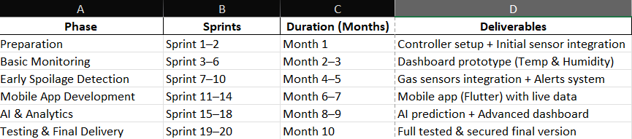
Figure 1: Gantt Chart

1.7 Summery
In this chapter, the idea of the project, its goals and importance in monitoring food safety during transportation were presented, while clarifying the research problem related to the impact of food on environmental factors inside trucks. The purpose of the project and its detailed objectives were also determined, the beneficiary categories and the expected benefits of the system were reviewed. An overview of the current systems used in food control was also presented, with their advantages and disadvantages, and what distinguishes our project from them. Finally, the methodology followed in the development of the project and its implementation time plan were briefly presented.

SYSTEM ANALYSIS

Introduction
This chapter provides a comprehensive analysis of the system's functional and non-functional requirements. It outlines the features and functionalities of the application and presents the technical specifications needed for development

Functional Requirements
Functional requirements involves clearly describing what the system should do — the specific behaviors, features, and functions it must support. The following provide description the system functional requirments.
Example of writing the function based on software engineering formal writing

Example First you write the function name and give it and id
Function name (FR_001)
Provide a description of this function and then use this table to fill the information about this function
Field | What It Means | What to Include for Other Functions
ID | A unique identifier for the requirement | Use a consistent format like FR_002, FR_003, etc.
Title | A short, descriptive name of the function | E.g., "user log in", "Payment Processing", "Admin Dashboard"
Description | A brief explanation of what the function does | What the system should do and why it's important
Priority | Importance level (e.g., Must-Have, Should-Have, Nice-to-Have) | Helps prioritize development and testing
Actors | Who interacts with this function | E.g., User, Admin, System,
Inputs | What data or actions trigger the function | E.g., form fields, button clicks, uploaded files
Outputs | What the system returns or does in response | E.g., confirmation messages, redirection, data updates
Pre-conditions | What must be true before the function can happen | E.g., user must be registerd ,
Post-conditions | What should be true after the function is completed | E.g., logged in to main page
Flow | Step-by-step process of how the function works | Describe the user/system interaction in logical order
Acceptance Criteria | Conditions that must be met for the function to be considered successful | Use measurable, testable outcomes

Example

User Login (FR_001):
The User Login functionality allows registered users to access the platform securely using their email and password. This requirement supports session management, error handling for invalid credentials, and account security through lockout mechanisms. It is a core feature of the authentication module and integrates with user registration and password reset functionalities.

Table 1 Functional Requirement – User Login
Field | Details
ID | FR_001
Title | User Login
Description | The system shall allow registered users to log in using their email and password.
Priority | Must-Have
Actors | Registered User, System
Inputs | Email address, password, "Login" button click
Outputs | - Authenticated user is redirected to the dashboard  - Error message displayed for invalid credentials
Pre-conditions | - The user is registered with a valid email and password  - The system is online and accessible
Post-conditions | - Valid credentials: user is logged in and redirected  - Invalid credentials: error message shown  - Locked account: user is notified to contact support
Flow | 1. User navigates to login page  2. Enters email and password  3. Clicks "Login"  4. System validates credentials  5. Redirects or shows error message
Acceptance Criteria | - Valid credentials grant access within 2 seconds  - Invalid credentials show error without redirect  - 5 failed attempts lock account  - Failed attempts are logged  - Login page handles up to 5s latency

Example of writing the function using scenarios and userstory based on scurm methodology
Title: User Login
Actor: Registered User
Description:
Sarah, a Registered User, opens the platform to start her day. She quickly enters her email and password, and the system logs her in smoothly, showing her dashboard with upcoming tasks. One day, she mistypes her password and sees an error message, but after correcting it, she logs in successfully. After multiple failed attempts, her account locks temporarily, and she receives clear instructions to contact support. Throughout, Maria feels the process is fast, secure, and reliable.
User Stories for user login
- User Story (US_001): As a user, I want to log in with my email and password so that I can access my dashboard.
- User Story (US_002): As a user, I want to see an error message when I enter an incorrect password so that I know to try again.
- User Story (US_003): As a user, I want my account to lock after multiple failed login attempts so that my account is secure.
- User Story (US_004): As a user, I want the login page to remain responsive even with slow internet so that I can have a smooth experience.
Inputs:
- Email address
- Password
- "Login" button click
Outputs:
- Authenticated user is redirected to the dashboard
- Error message displayed for invalid credentials
- Lockout notification after multiple failed attempts
Pre-conditions:
- The user is registered with a valid email and password
- The system is online and accessible
Post-conditions:
- Valid credentials: User is logged in and redirected to the dashboard
- Invalid credentials: Error message is shown
- Locked account: User is notified and advised to contact support

Main Flow :
- User navigates to the login page
- User enters email and password
- User clicks the "Login" button
- System validates the credentials
- If valid, the user is redirected to the dashboard
Acceptance Criteria:
- Valid credentials grant access within 2 seconds
- Invalid credentials show an error without redirect
- 5 failed login attempts result in account lockout
- All failed attempts are logged
- Login page handles up to 5 seconds of latency gracefully

Function 2 (FR_002):

Table: Functional Requirement – Function 2
Field | Details
ID | FR_002
Title
Description
Priority
Actors
Inputs
Outputs
Pre-conditions
Post-conditions
Flow
Acceptance Criteria

Function 3 (FR_003):

Table: Functional Requirement – Function 3
Field | Details
ID | FR_003
Title
Description
Priority
Actors
Inputs
Outputs
Pre-conditions
Post-conditions
Flow
Acceptance Criteria

3. Dependencies
User Registration (FR_002): Users must be registered to have valid credentials.
Password Reset (FR_003): Users with locked accounts may need to reset their password.
Security Logging (FR_004): Failed login attempts are logged for monitoring

None- Functional Requirements
This section outlines the non-functional requirements that define the quality attributes of the system. These requirements ensure the system is secure, user-friendly, and compliant with modern web standards.

Security
NFR_001: The system must use SSL/TLS encryption to ensure secure data transmission between the client and server.
NFR_002: All passwords must be stored using secure hashing algorithms.
NFR_003: The system must implement account lockout after 5 consecutive failed login attempts to prevent brute-force attacks.

Privacy
NFR_004: The system must provide a clear and accessible privacy policy outlining how user data is collected, stored, and used.
NFR_005: Users must be able to view, update, or delete their personal data in compliance with data protection regulations .

Ease of Use
NFR_006: The application must have a responsive design that works seamlessly on desktops, tablets, and mobile devices.
NFR_007: The user interface must be intuitive and easy to navigate, with consistent layout and labeling.

Requirements Modelling UML
Unified Modelling Language (UML) is a standardized modelling language used in software engineering to visualize, specify, construct, and document the structure and behavior of software systems. UML diagrams help simplify complex system designs by providing a clear and structured representation of system components and their interactions. This section presents the key UML diagrams used to model the School System Login Module.

Use Case Diagram
The Use Case Diagram provides a high-level overview of the login functionality in the school system. Figure 1 shows interactions between actors such as Students, Teachers, and Administrators with the system. Key use cases include Login, Password Recovery, and View Dashboard.

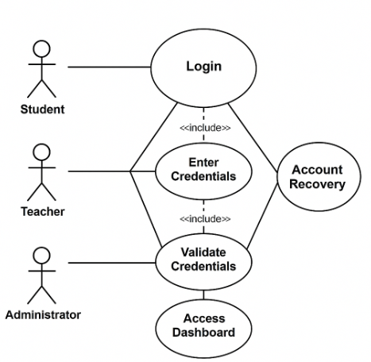
Figure 2– School System Login

Sequence Diagram
The Sequence Diagram illustrates the step-by-step interaction between a user and the system during the login process. Figure 2 shows how the user inputs credentials, how the system validates them, and what happens based on the result.
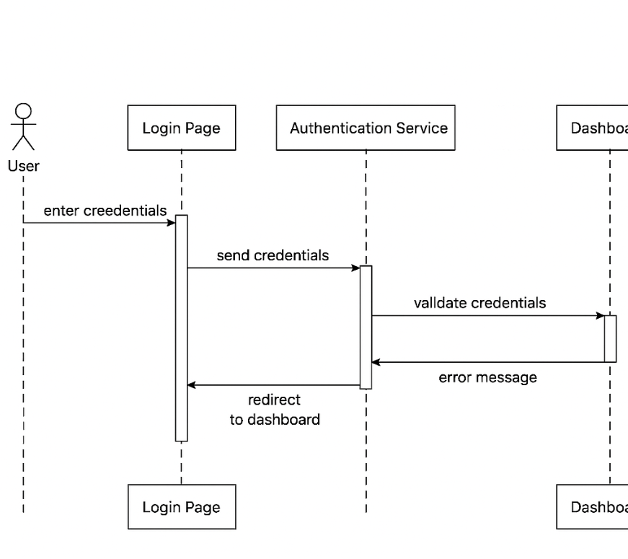
Figure 3 Sequence Diagram – User Login

Activity Diagram
The Activity Diagram represents the flow of actions during the login process. It includes steps like entering credentials, validation, success/failure paths, and redirection to the appropriate dashboard.

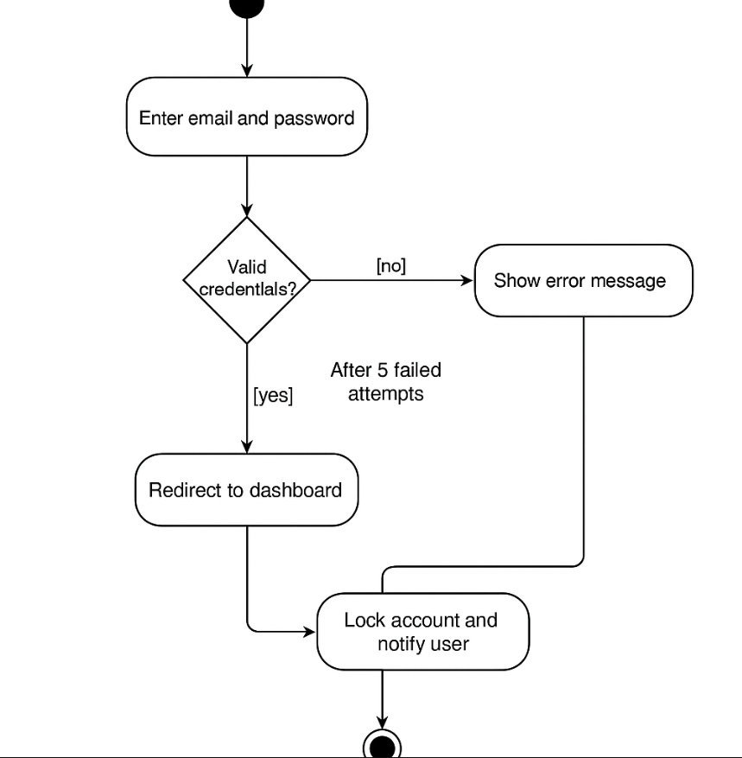
Figure 4 Activity Diagram – Login Process

Class Diagram

The Class Diagram shows the static structure of the login module. It includes classes such as User, LoginManager, and Session, along with their attributes and methods. Relationships between these classes are also illustrated.

Figure 4: Class Diagram – Login Module
(To be inserted: a diagram showing class names, attributes, methods, and associations)

Summary

DESIGN CONSIDERATIONS

Introduction
Design considerations include various elements such as functionality, usability, scalability, performance, maintainability, security, compatibility, and cost. we will create high-quality software that meets the needs of the users, while also meeting the requirements and specifications of the project.

Architectural Strategy
A well-defined architectural strategy is a foundational element of any software system. It encompasses the core components and services that collectively deliver the system’s functionality, performance, and user experience.In a typical application, when a user performs an action (e.g., submitting data), the system processes the input, stores it securely, and provides real-time feedback or updates based on predefined logic and rules. The architecture is commonly structured into three main layers which promotes scalability and maintainability.

Presentation Layer (User Interface Layer):
This is the front-facing part of the system where users interact with the application. It provides an intuitive and responsive interface for performing tasks such as data entry, navigation, and viewing reports or analytics.

Business Logic Layer (Processing and Notifications):
This layer handles the core logic of the application. It processes user inputs, enforces business rules, performs calculations, and triggers system responses such as alerts, validations, or automated actions. It ensures that the application behaves as expected under various conditions.

Data Layer (Storage and Synchronization):
This layer is responsible for storing and managing application data. It ensures data consistency, security, and availability across devices and sessions. It may involve cloud databases, local storage, or hybrid solutions, and supports real-time synchronization when needed.

Development Requirements

Hardware Requirements
Explain the hardware that you will use to develop the project
  - Computer/laptop for development (PC, Acer Laptop).
  - Stable internet connectivity.
  - Development server for testing.
  - Standard peripherals like keyboard, mouse, and monitor.
  - Backup solutions for data protection.

Software Requirements
To develop the system, the following software components are needed:
- Operating System: Windows 11
- A Server: A web server such as Apache or Nginx is required to manage the application content (XAMPP).
- Back-end development programing languages and frameworks: required for the system development- Backend.
- Lang1
- Lang2
- Lang3
- Frontend programing languages and frameworks: Required for the system development- Frontend
- Lang1
- Lang2
- Lang3

Graphic User Interface Design and wireframe
Show the UI interface design of the product. Also explain the wireframe is how the app or the site move from one page to another.
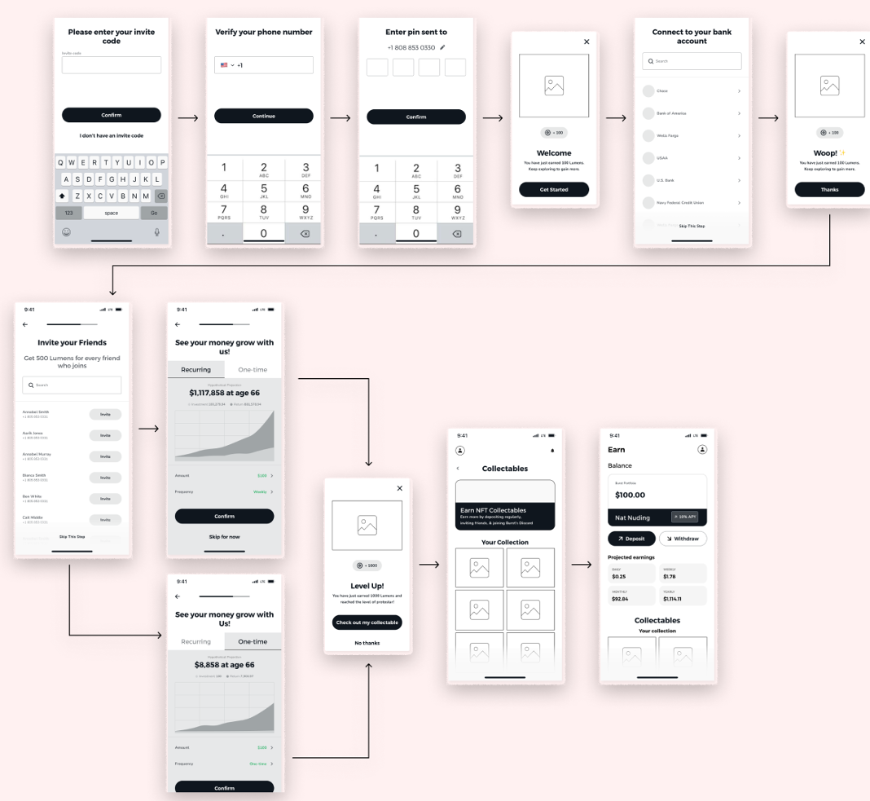

Figure 5 Example of product wireframe and UI

Summary
Summry of the chapter

CONCLUISON

Introdction

This chapter provides a comprehensive overview of our project, highlighting the challenges we encountered, the timeline of our work, and insights into future development. It concludes with a summary of the entire report.

Challenges and learning experiences
Expalin the challenges that your team faced during the project, and what have learnd form this project

Timeline
Illustrate the project time line

Furture work
Here your explain what will your team do In project 2

Conclusion
Provide a full summary of this project report

Reference:

